**DAILY ONLINE ACTIVITIES SUMMARY**

|  |  |  |  |
| --- | --- | --- | --- |
| **Date:** | 10/07/2020 | **Name:** | Krishnitha |
| **Sem & Sec** | 4th sem, A Section | **USN:** | 4AL18CS039 |
| **Online Test Summary** | | | |
| **Subject** | Object Oriented Concepts | | |
| **Max. Marks** | 30 | **Score** | NA |
| **Certification Course Summary** | | | |
| **Course** | Salesforce User Basics | | |
| **Certificate Provider** | Sales force | **Duration:** | 3 hrs |
| **Coding Challenges** | | | |
| **Problem Statement:**  Write a java program to find ASCII code of a character. | | | |
| **Status:** Executed | | | |
| **Uploaded the report in GitHub** | | YES | |
| **If yes Repository name** | | <https://github.com/krishnitha/Java-coding> | |
| **Uploaded the report in slack** | | YES | |

**Descriptive Test Details:**

Today we had test in “Object Oriented Concepts” subject. The assessment was based on first module of this subject. The test consisted of four questions of 7.5 marks each.

**Certification Course Details:**

Today I started the new course “Salesforce User Basics” by Sales Force. Today I learnt about how to organize the data and how to deal with bugs.

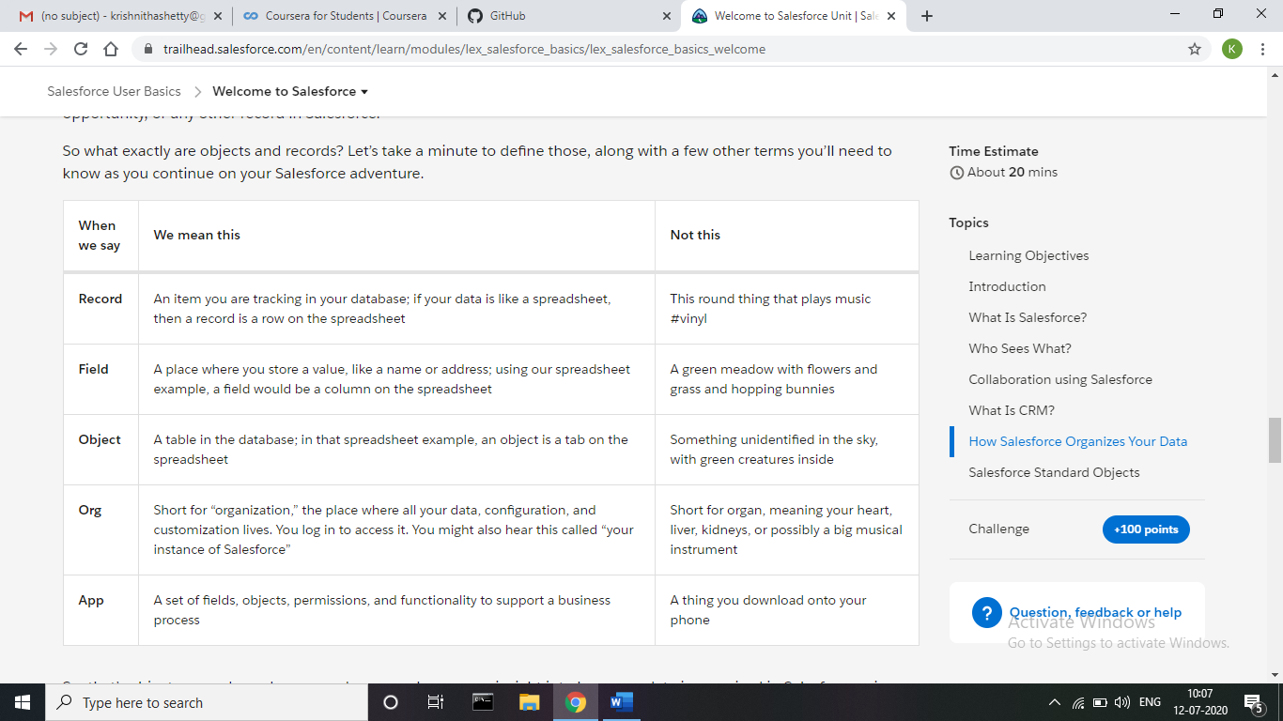

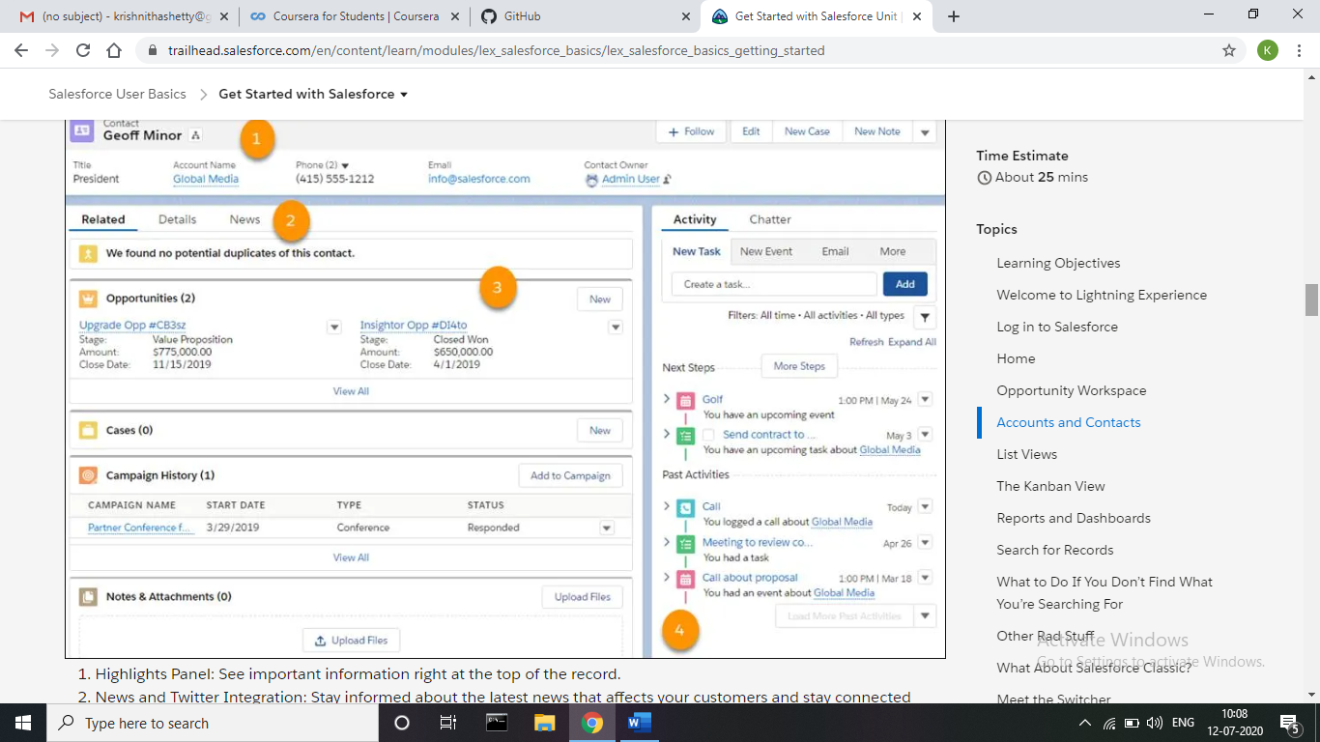

**Coding Challenges Details:**

**Problem:** Write a java program to find ASCII code of a character.

**Output:**

ASCII value of P is: 80

ASCII value of P is: 80

**Solution:** Uploaded it in GitHub

